**S.R. INTERNATIONAL ACADEMY**

NAME_______________________________

ROLL NO.__________

DATE______________

**GAJPUR, BANSPAR, GORAKHPUR**

**PRE- MID TERM EXAM**

**SESSION 2024-25**

**CLASS – 2ND ( )**

**SUB- COMPUTER MM:40**

**Q.1. Tick the correct option: 1x8=8**

**1.**A computer is a/an .........................machine.

a) conical b) electronic c) simple

**2**.This part looks like a television.

a) CPU b) Monitor c) Notepad

**3.** The desktop computer can be kept on the......................

a) palm b) table c) Lap

**4**. A........................has a touch screen display.

a) tablet b) laptop c) palmtop

**5.** It is also known as thebrain of the computer.

a) CD b) UPS c) CPU

6. ........................can be kept on our lap?

a) palmtop b) tablet c) Laptop

**7.**This part keeps the computer ON when the electricity goes off.

a) CPU b) DVD c) UPS

**8.**This part is use to store information.

a) joystick b) Hard disk c) Mouse

**Q.2. Fill in the blanks: 1x10=10**

**slower, scanner, mouse, Pendrive, palmtop, VDU, buttons, feelings, electronic, desktop**

**1.** The computer is an _____________ machine.

**2.** A monitor is also known as_____________.

**3.** A ______________computer can not be moved from one place to another easily.

**4**. ______________ computer can be kept on the palm.

**5.** A mouse has two______________ and a scroll wheel.

**6.** The _____________ is use for selecting objects on the screen.

**7.** Human beings work ______________than computers do.

**8**.______________ is also called Flash drive.

**9**.Human beings have _____________ but computer do not have any.

**10**. The _____________ copies the text and pictures from a page onto the computer.

**Q.3. Write (T) for true and (F) for false 1x10=10**

**1.**The computer has two main parts.

**2.** A desktop computer can be carried anywhere.

**3.** Laptop computers can be used in cars.

**4.** All the part of a computer remain connected with cables.

**5.** The monitor displays what we do on the computer.

**6.** A computer has no thinking power and emotions.

**7.** The keyboard is the brain of the computer .

**8.** A computer gets tired in a few hours.

**9.** The mouse is a pointing device.

**10.** Human beings naver make mistakes.

**Q.4. Match the names of computer parts with given pictures. 1x6+6**

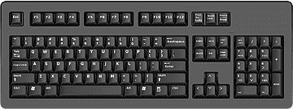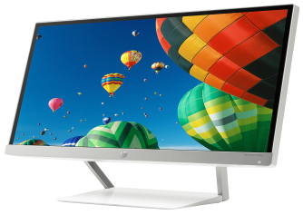

**CPU**

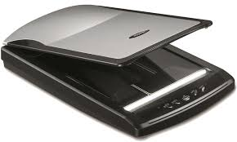

**Keyboard**

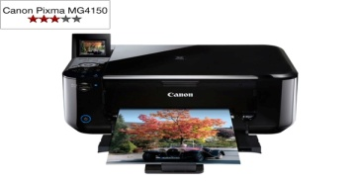

**Monitor**

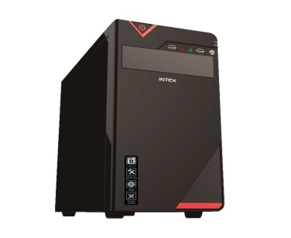

**Mouse**

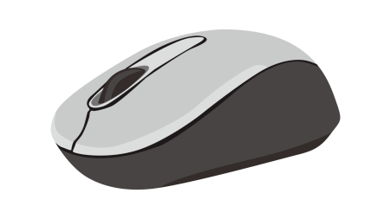

**Scanner**

**Printer**

**Q.9. Answer the following questions: (Any 4 ) 1.5x4+6**

1. Which part of the computer do we use for writing text.

Ans.

2.What can we do with the help of a computer?

Ans.

3.Can a computer work for long hours without taking rest?

Ans.

4.What are the four main parts of computers?

Ans.

5. What are different types of computer?

Ans.

6. what is the use of pendrive?

Ans.